

Weeds Action Fund Grants

GRANT APPLICATION FORM

Due Date:

# **PART A: Applicant and Property Details**

|  |  |  |  |  |  |  |  |  |  |  |  |  |  |  |  |
| --- | --- | --- | --- | --- | --- | --- | --- | --- | --- | --- | --- | --- | --- | --- | --- |
| |  |  | | --- | --- | | Applicant name: | **SCAGI – Seymour Community Action Group Inc.** | | Contact person (if a Group) | **Daniel Steiner / Quentin Smith** | | Postal Address: | **PO Box 25** | | Property Address: | **Crown Land – Seymour Wetland – Champ Street Seymour 7215** | | Property ID (PID) | **6406669** | | Phone Number: | **0425 232 000** | | Email: | **scagi7215@gmail.com** |   **Incorporation Number (for groups only): IA 11990** |  |

(If your group is not incorporated your project will need to be sponsored, please provide sponsorship details below)

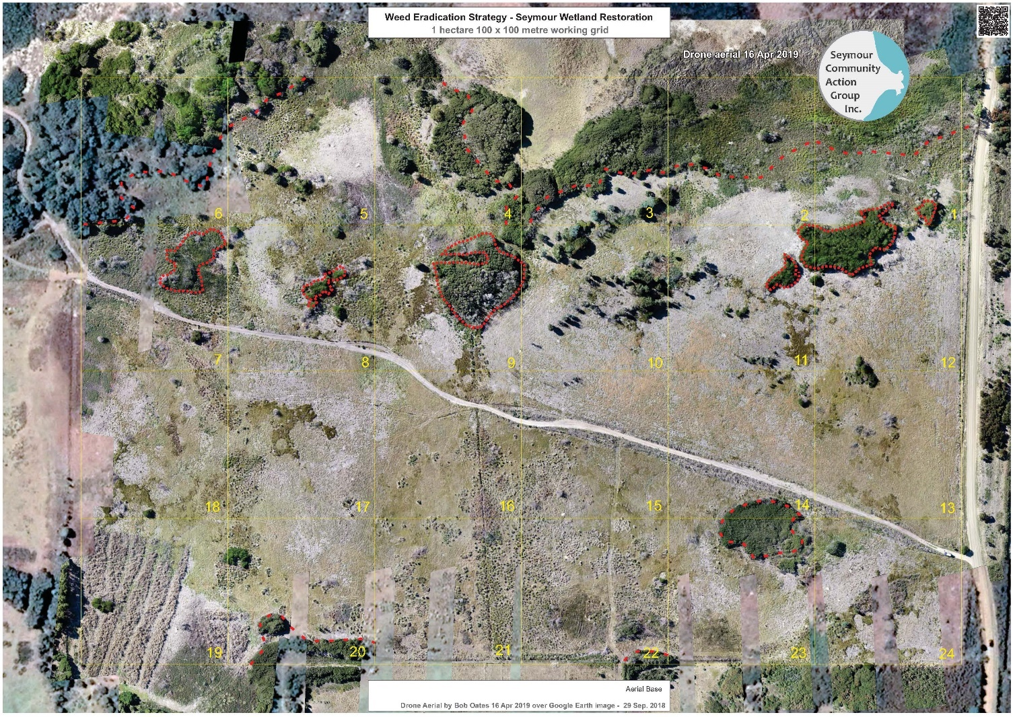

Area B

Area C

Area A

**PART B: Project Details**

# Seymour Wetland Restoration – Weed eradication

|  |
| --- |
|  |
|  |
| * Project Description. If you have multiple sites, please number each site (e.g. Site 1, Site 2). Identify these separately in your description. Include sites on the map and in the Project Plan & Budget (PART C). * Explain why the project is important, for example the target weed(s) is listed as a high priority weed; or the weed(s) are impacting threatened species or important agricultural assets. |
|  |
| The importance of our project is its restoration quest to a valuable environmental asset. The wetland is habitat of three endangered species and part of a wider foreshore wetland system with an adjacent saltwater wetland and a tidal lagoon.  Site: The Crown Land site was classified Seymour Conservation Area in 2002 but major gorse infestation saw it being reversed to Public Reserve. SCAGI have been committed to rid the area of weeds since a fuel reduction burn in 2016. There has been over 16 hectares of burnt gorse mulched and subsequently sprayed with weed killer. The project contributes to setting an example to adjoining properties and farms in the Seymour area. Our aim is the restoration of the Seymour wetland to its natural habitat for flora and fauna and to have the area once again included in the Seymour Conservation Area.  Purple shading is the whole wetland site and the orange  outline is “Area A” subject to this application.  SCAGI’s history and endeavours meet the programs objectives in the following areas:   * we have made a commitment to weed mitigation in a strategic and targeted approach which is documented in our Weed Management Plan and reported extensively on our website. <https://scagi7215.wixsite.com/scagi> * we encourage our neighbouring farm properties to take responsibility by assistance and setting a good example.   Numerous working bees have been carried out to rid the peripheral vegetation of weeds and any flowering gorse regrowth. All activities have been logged on our website on a day to day basis.  We are seeking funding for the second round of weed spraying by contractors which we plan to do in two stages; East and West of the access track to the beach. This grant application is for the area to the west of the access track. We then plan to commence planting native trees in 2020. The collected local seeds are propagating at Habitat Nursery and will be purchased from them for planting. Please see attached maps showing the second round of spraying, East and West and initial re-vegetation programme. The following areas are indicated on the aerial of the following map.   * Area A: Overall area subject to this grant application. * Area B: A remaining burnt gorse stalks site which has not been mulched yet. * Area C: The initial re-planting site along Champ Street.   **A close up of a map  Description automatically generated**  East side Area - Subject to a Landcare Grant application  [**Link to current - 2019 05 - Seymour Weed Management Plan in pdf 6.2MB**](https://docs.wixstatic.com/ugd/ebbc25_e7bb10ffac55474bacd093d36cf317aa.pdf)  https://docs.wixstatic.com/ugd/ebbc25_e7bb10ffac55474bacd093d36cf317aa.pdf  **Known Values of Seymour Wetland:**   * Vegetation buffer to Templestowe Beach and Templestowe Lagoon. * Spawning and feeding habitat for many fish species such as the Australian grayling Prototroctes maraena. * Feeding and nesting habitat for endemic and migratory birds such as the Pacific Golden Plover Pluvialis fulva, Sharp‐tailed Sandpiper Calidris acuminata, and Ruddy Turnstone Arenaria interpres. * Habitat for threatened species such as the Green and Gold Frog Litoria raniformis and flora species such as leafy flatsedge Cyperus lucidus. * Supports threatened vegetation communities of Melaleuca ericifolia swamp forest (NME) and Fresh water aquatic sedgeland and rushland (ASF) * Habitat for the endangered listed Tasmanian Devil Sarcophilus harrisii and the vulnerable listed white‐bellied Sea Eagle Haliaeetus leucogaster as well as for the Tasmanian Wombat Vombatus ursinus tasmaniensis. * Water levels within the freshwater marsh fluctuate seasonally with differing rainfall. The presence and health of endemic vegetation in swamp systems has impact upon the acidification levels of surrounding landscapes.  **Challenges:** * The site contains considerable infestations of Gorse Ulex europaeus as well as lesser infestations of other weeds such as Blackberry Rubus fruticosus, Spanish Heath Erica lusitanica, Montpellier Broom Genista monspessulana, Pampas Grass Cortaderia spp., and African Boxthorn. * The gorse, as it flourished in 2016 was a major fire hazard to the whole Seymour/Long Point community. * SCAGI has actively sought funding, in kind support and advice from various sources to support the attainment of their aims and objectives. We have organised and participated in numerous coordinated on ground working bees with excellent results. * We are committed to a long-term project, knowing that constant vigilance is required over a very long time to re-generate this important natural environment. * Funding and grant applications have been challenging as the local Council considers Crown Land not to be part of their responsibility.   A picture containing outdoor, mountain, grass, nature  Description automatically generated  Image looking east showing gorse infestation before the asset protection burns in 2016  **A close up of a dry grass field  Description automatically generated**  Area A |
| Subject site looking west over the beach access track sowing Area A to be treated in Spring/Summer 2019  Looking east the Seymour Freshwater Wetland shown in context to Templestowe Lagoon and its ecosystem.  Subject Site  A close up of a map  Description automatically generated  SCAGI has obtained competitive quotes from Contractors we have used in the past and their collective advice was to apply the next large-scale treatment in the Spring/Summer season of 2019. The contractors are: Maurice from All Weed Solutions; Amanda Brooks from “Private Works” Glamorgan Spring Bay Council & Jamie Cooper from Feral Weed Management. |

# **PART C: Project and Budget**

In sequence, explain the activities, timing, the person responsible and items (e.g. equipment, spray etc.) required, proposal costs and contributions.

All items must include GST where applicable

| **Timing** | **Activities** (breakdown of Project items and tasks for each stage, rows can be added and deleted as required) | **Amount of funding & item expense** | **In-kind contribution** |
| --- | --- | --- | --- |
| Spring 2019 | Engage contractor to spray all re-growth gorse and blackberry in Areas A, B and C. | $3000 | Supervision and organisation |
| Summer 2019/2020 | Revegetation including 300 trees seedlings guards and stakes | $750 | Group labour and planting |
| Autumn 2020 | Follow up backpack spraying of flowering regrowth around periphery and vegetation stands. Equipment: 3 battery powered backpack spray units and spray | $1250 | Group spraying labour |

***Total Project Value*** (include GST where appropriate)

|  |  |  |
| --- | --- | --- |
| **Project(s)** | **Total Amount of Funding Requested** | **Total In-kind Contribution** |
| Seymour Wetland Part A, B and C project | **$5000** | Organisation, supervision, planting and follow up spraying by SCAGI group |

# **ABN (if applicable):**

If you don’t have an ABN you will be required to fill out a statement of supplier form if your application is successful.

# **Are you registered for GST?**

Yes ☐  No x

# **PART D: Best Practice**

## Contractors

Are you using a contractor?

Yes x No ☐

* If yes please attach a quote for the activities that they are undertaking and ensure this is included in your Project Plan and Budget.
* When contractor costs are greater than 75% of total project costs at least two quotes will be required.
* Does your contractor hold a Commercial Operator’s License for spraying? Information on the requirements can found at: <https://dpipwe.tas.gov.au/agriculture/agvet-chemicals/licences-and-certificates/ground-spraying-and-pest-management-licences>
* Is your contractor registered for GST? If not and you as the applicant are registered for GST, you will have to add GST to the contractor amount in the budget table in Section C.

## Each of our previously used contractors Maurice from All Weed Solutions; Amanda Brooks from “Private Works” Glamorgan Spring Bay Council & Jamie Cooper from Feral Weed Management hold a Commercial Operators License and are registered for GST. The quote is in progress and will be attached if it arrives in time.

## Methods

SCAGI will provide the contractor with mapping of the site and provide the water necessary for the spraying. We will monitor and give feedback of the results to the contractor. In the past we have also assisted BODC with an extra person spraying on the second hose.

The planting is proposed to be undertaken by SCAGI with all the follow-up requirements.

The methodology is outlined in our Management Plan with [a link to it here](https://docs.wixstatic.com/ugd/ebbc25_fcc6f07ebf1043c8a648ce86b6a92159.pdf).

SCAGI will purchase 3 battery powered backpack spray units and spray for follow-up treatments later in 2020 and in the winter.

We consult with Fiona Everts PWS designated Ranger for the Project and NE Bioregional Network Ecological Consultant Todd Dudley regularly. We also seek advice from DPIPWE Phil Thompson. We discuss the WMP with the different contractors to ensure best practice as laid out in the Plan are followed. We have had two Field Days with experts from Landcare Tas, NRM, PWS, Birds Tas and the NE Bioregional Network giving talks to the Group about the Project.

We have a committed and enthusiastic community care group that have already put in significant hours in managing gorse in and around the wetlands. We will continue applying for grants. Collect native seeds from the area for propagation and revegetation in 2020. Continue with weed control as outlined in our WMP utilizing contractors, volunteers and group members. Continue to recruit new members and run Field Days to educate people about the Project and the natural value of the area.

|  |
| --- |
|  |

## Technical Advice (if applicable)

From whom have you received advice and guidance in developing your project proposal?

|  |  |  |  |
| --- | --- | --- | --- |
| **Name** | **Support provided** | **Contact No** | **Organisation** |
| Fiona Everts | Weed Management Plan | 03 6256 7070 | Parks |
| Todd Dudley | Seymour Swamp ecological restoration project (Phase 2) | 03 6376 1049 | NE Bioregional Network |

## Ongoing Site Maintenance

SCAGI is committed for the long term necessary to achieve our goals. We will have to continue looking for funding into the future.

|  |
| --- |
|  |

## Existing Management Plans

Yes x No ☐

**Gorse Eradication Strategy for Seymour Wetlands Restoration**

**2019-05 update**

https://docs.wixstatic.com/ugd/ebbc25_e7bb10ffac55474bacd093d36cf317aa.pdf

|  |
| --- |
|  |

# **PART E: Other Important Information**

## Property Ownership

# Do you own the property where the proposed activities will occur?

Yes ☐ **No X**

## Cultural Heritage Values

Has a cultural heritage survey been completed on your proposal site?

Please provide the title and/or a copy of the plan if available.

Unsure **X** Yes☐ No ☐

|  |
| --- |
| If yes provide details (i.e. title, date)  REF 254945 - Aboriginal Heritage Assessment Standing Requirements regarding Weed Management & Weed Re-vegetation - Champ St, Seymour : (PS0065617) Seymour Community Action Group Inc.  Keating, Claire (Heritage) <[Claire.Keating@heritage.tas.gov.au](mailto:Claire.Keating@heritage.tas.gov.au)>  **Sent:** Thursday, 27 June 2019 11:31 AM |

If unsure or not completed, your project may require a survey and successful applicants will be notified of any further requirements.

## Insurance

Do you have public liability insurance?

Yes **X** No ☐

## Past Projects

Have you received any grants in the past 5 years? If yes, please provide details of amount and funding source, and when the project is due for completion.

Yes  **X** No ☐

|  |  |  |  |
| --- | --- | --- | --- |
| **Funding source** | **Completion date (or active)** | **Title and brief description** | **Amount received** |
| DPIPWE | 2019 | Mulching and First round of Spraying | $7900 |
| RACT | 2019 | Field Day, Cut and Pasting and Spraying | $1500 |
| NRM North | 2018 | Mulching and First round of Spraying Field day and training | $5000 |
| BODC | 2017 | Mulching and First round of Spraying Car Park & Interpretive sign | $5000 |
| SCAGI & EON | active | Mulching, Spraying, Working Bees Field Days | $10500 |
| Landcare TAS | active | LAP Grants for Insurance and Admin costs | $310 |

Department of Primary Industries, Parks, Water and Environment

GPO Box 1751, Hobart, TAS 7001 Australia

Ph 1300 TAS PARKS / 1300 827 727 Fax 03) 6223 8308 [www.parks.tas.gov.au](http://www.parks.tas.gov.au/)

31 May 2019

Seymour Community Action Group Inc. C/- Mr Quentin Smith

PO BOX 25

BICHENO TAS 7215

Email to: [sacagi7215@gmail.com](mailto:sacagi7215@gmail.com)

**Enquiries:** Gerry Murrell

**Ph:** (03) 6165 3065

**Email:** [propertyservices@parks.tas.gov.au](mailto:propertyservices@parks.tas.gov.au)

**Our ref**: LM-LM-AU-CW-254945

Dear Mr Smith,

I refer to your Works Application seeking Crown consent to undertake weed eradication on Crown land, Champ Street, Seymour (PID 6406669 – as illustrated in attachment).

Pursuant to Section 3 of the *Crown Lands Act 1976,* the Seymour Community Action Group Inc. (and its agents, contractors and sub-contractors) is authorised to undertake the proposed works subject to the following conditions:

1. Compliance with any local government authority planning and/or building requirements. Should Permits be required, they must be provided to Crown Land Services prior to commencement of any works.

2. Compliance with requirements of relevant authorities including, but not limited to, Worksafe Tasmania, the Local Government Authority and the Policy Conservation Advice Branch (Department of Primary Industries, Parks, Water and Environment).

3. Permissible activities include:

a) Weed removal;

b) Use of selective herbicides; and c) Rubbish removal.

4. Non-permissible activities include:

a) Damage or removal of native vegetation;

b) Use of ‘heavy’ machinery and equipment; and

c) Digging and soil disturbance.

5. Removal of weeds must be in accordance with the Statutory Weed Management Plan for each species. Guidelines are available at: <http://dpipwe.tas.gov.au/invasive-species>

6. Herbicides must be applied in accordance with Department and Primary Industry, Parks, Water and Environment’s (“DPIPWE”) guidelines. The guidelines are available at:<http://www.dpipwe.tas.gov.au/weeds>

7. Compliance with the ‘Weed and Disease Planning and Hygiene Guidelines’, published by

DPIPWE, 2015 The guidelines are available at:

[http://dpipwe.tas.gov.au/Documents/Weed%20%20Management%20and%20Hygiene%20Guid elines.pdf](http://dpipwe.tas.gov.au/Documents/Weed%20%20Management%20and%20Hygiene%20Guidelines.pdf)

8. All trimmed vegetation must be removed from the Crown land and disposed of in accordance with Council requirements.

9. All mechanical machinery, must be operated by qualified operators using suitable safety equipment.

10. Works must be carried out in a manner to ensure the safety of other users of the Crown land.

11. The Crown accepts no responsibility for ongoing maintenance associated with these works.

12. Any damage to the subject Crown land, be it inadvertent or intentional, must be rehabilitated to the satisfaction of the Manager, Crown Land Services.

13. The Seymour Community Action Group Inc., and any agent, contractor or sub-contractor, must hold suitable Public Liability Insurance for the proposed works.

14. All agents, contractors and sub-contractors must comply with the conditions of this Authority.

15. A copy of this Authority must be carried while undertaking the permissible activities on the subject Crown land and shown to an authorised officer on request.

16. Notwithstanding the conditions of this Authority, the Seymour Community Action Group Inc. (and its agents, contractors, sub-contractors and volunteers) must comply with any direction given by an authorised officer.

17. Persons entering or conducting activities on Crown land pursuant to this authority do so entirely at their own risk. Liability is not accepted by the State of Tasmania or the Department of Primary Industries Parks Water & Environment for any injury, loss or damage suffered by any such persons, whether resulting from negligence or any other cause.

18. This Authority is valid to the 30 June 2021.

Should you require the Authority to be extended you will need to apply in writing.

The issue of this Authority does not imply that approval required under any other legislation or by- law is granted. It is the responsibility of the holder of this Authority to ensure that all necessary approvals are obtained.

If you require more information please contact the officer nominated at the head of this correspondence.

Yours sincerely,

Jesse Walker

**Team Leader (Unit Manager Policy and Projects) Crown Land Services**

